Angular: is a js framework which allows you to create reactive single page applications(SPAs)

no refresh

change the DOM at runtime

joined https://discordapp.com/invite/gxvEWGU

Angular 8:

versions

Angular 1

completely rewritten

Angular 2(2016)

Angular 4

.

.

8

they usually change every 6 months.

there are no major changes and also maintain backward compatibles.

1 -> 2 is the major one

Angular CLI is the best command line interface for angular

node package manager

download and install node.js(server side code) and run following:

npm install -g npm --> install globally

[sudo] npm uninstall -g angular-cli @angular/cli --> install globally

npm cache clean

[sudo] npm install -g @angular/cli

we use node.js for npm

npm install -g @angular/cli@latest

set up a project in the required project:

run this cmd "ng new my-first-app"

and set it up by answering some questions

Bring the dev server:

ng serve

the project created has following:

package.json file -> has all the dependencies.

e2e -> end to end testing

node_modules -> modules needed for the project.

src -> app ->component files.

app.component.ts -> typescript file ->it is converted into js and used

the html and css, js in the app folder are the display pages

To use directives import respective in app.module.ts

directives -> ng model

check example

Course Structure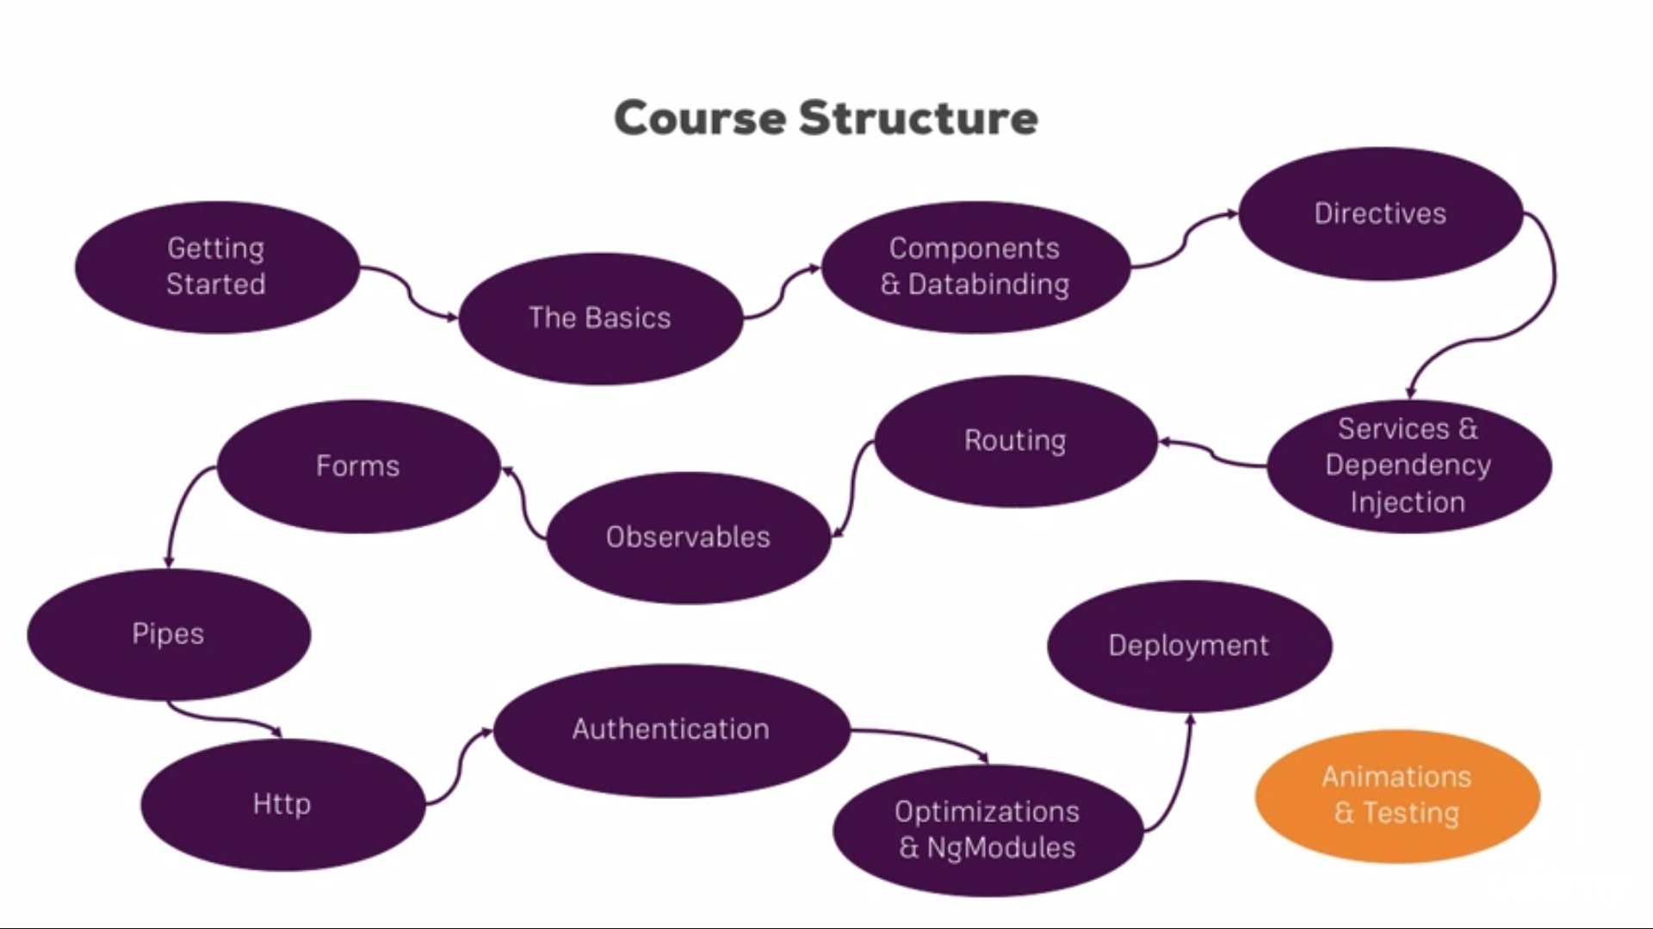

Loading dynamic components